### SSN COLLEGE OF ENGINEERING

**Department of Computer Science and Engineering CS6712 Grid and Cloud Computing Laboratory**

##### Assignment -6 : Private Cloud Setup using Eucalyptus

**Assigned Date: Due Date:**

1. Install Eucalyptus (Open Source software for Private Cloud) by configuring the below components.
   * Cloud Controller (CLC) on VM1 with ubuntu-UEC-10.04-server-amd64
   * Cluster Controller (CC) on VM1 with ubuntu-UEC-10.04-server-amd64
   * Walrus on VM1 with ubuntu-UEC-10.04-server-amd64
   * Storage Controller (SC) on VM1 with ubuntu-UEC-10.04-server-amd64
   * Node Controller (NC) on VM2 with ubuntu-UEC-10.04-server-amd64
   * Client to access Cloud components on VM3 with ubuntu-16.04.1-desktop-amd64 Follow the Eucalyptus Documentation in the below link.

https://help.ubuntu.com/community/UEC/CDInstall https://help.ubuntu.com/community/UEC/PackageInstall

Follow below steps

1. Install Virtual Box.
2. Create two VMs as VM1 and VM2.
3. Configure network as DHCP and don’t use Ethernet.
4. Use Bridged network along with DHCP. Ping and check correctness
5. Install Ubuntu 10.04 Server in both VMs
6. In VM1 install components like (Cloud controller, Cluster Controller, Walrus and Storage Controller)
7. In VM2 install Node controller.
8. In VM3 Web Interface, login as https://<cloud-ip>:8443 Username: admin

Password: admin

Check all the resources available.

In Client Ubuntu-Desktop, do the following.

1. https://<cloud-controller-ip-address>:8443/
2. Use username 'admin' and password 'admin' for the first time login (you will be prompted to change your password).
3. Then follow the on-screen instructions to update the admin password and email address.
4. Once the first time configuration process is completed, click the 'credentials' tab located in the top-left portion of the screen.
5. Click the 'Download Credentials' button to get your certificates
6. Save them to ~/.euca
7. Unzip the downloaded zip file into a safe location (~/.euca)

]$ unzip -d ~/.euca mycreds.zip

1. **On Cloud controller run the following command**

]$ sudo start uec-component-listener

Alternatively, if you are on the command line of the Cloud Controller, you can run:

]$ mkdir -p ~/.euca

]$ chmod 700 ~/.euca

]$ cd ~/.euca

]$ sudo euca_conf --get-credentials mycreds.zip

]$ unzip mycreds.zip

]$ ln -s ~/.euca/eucarc ~/.eucarc

]$ cd -

1. **Source eucarc using the command ]**$

]$ **source eucarc**

Or

**]$ . ~/.euca/eucarc**

1. **Install euca2ools in client machine.**

**Download euca2ools debian package for Ubuntu 16.04 Desktop amd64**

https://ubuntu.pkgs.org/16.04/ubuntu-main-amd64/euca2ools_3.1.0-1_all.deb.html

]$ sudo apt-get update

] $ sudo apt-get install <euca2ools-package>

To Download euca2ools rpm package

https://docs.eucalyptus.com/eucalyptus/latest/#shared/installing_euca2ools_rhel.html To convert rpm to debian package to be executed in Ubuntu 16.04 Desktop

**First install packages that will convert rpm packages to Debian**

]$ sudo apt-get install alien dpkg-dev debhelper build-essential

**Now convert package from RPM format to Deb format, use the following command. Change your packagename in command:**

]$ sudo alien packagename.rpm

**To install the deb package**

]$ sudo dpkg -i packagename.deb

]$ sudo apt-get -f install

1. **Execute euca commands for the following.**

]$ euca-describe-images

]$ euca-describe-instances

]$ euca-describe-availability-zones

]$ euca-describe-keypairs

1. **Creating Keypairs**

]$ euca-add-keypair mykey | tee mykey.private

]$ chmod 0600 mykey.private

1. **Using Block Storage Creating a volume**

To create a dynamic block volume, use "euca-create-volume."

For instance, to create a volume that is 1GB in size in the availability zone "myzone" you may use the following command,

]$ euca-create-volume --size 1 -z <cluster-name>

]$ euca-describe-volumes

**Creating a snapshot**

You may create an instantaneous snapshot of a volume. A volume could be attached and in use during a snapshot operation.

For example, to create a snapshot of the volume "vol-33534456" use the following command

]$ euca-create-snapshot vol-33534456

**Deleting a volume:**

]$ euca-delete-volume vol-33534456

1. **Using Object Storage**

**How to use s3cmd with Eucalyptus for accessing Walrus**

https://github.com/eucalyptus/eucalyptus/wiki/HowTo-use-s3cmd-with-Eucalyptus

1. **Managing Images in Eucalyptus**

**Creating an Image, register in Eucalyptus and creating a VM instance from the image.**

Download some mini version of linux iso image

https://ftp.yzu.edu.tw/Linux/kali-images/kali-2018.2/kali-linux-2018.2-amd64.iso Registering image in Eucalyptus

https://cssoss.wordpress.com/2010/11/11/eucalyptus-beginner%E2%80%99s-guide-%E2%80%93- uec-10-10-eucalyptus-2-0-image-management/

**Refer the Eucalyptus installation paper for working on it further.**

1. **Controlling eucalyptus services:**

* **]$ sudo service eucalyptus** [start|stop|restart] (on the CLC/CC/SC/Walrus side)
* **]$ sudo service eucalyptus-nc** [start|stop|restart] (on the Node side)

##### Locations of some important files:

* **Log files:**
  + /var/log/eucalyptus
* **Configuration files:**
  + /etc/eucalyptus
* **Database:**
  + /var/lib/eucalyptus/db
* **Keys**
  + /var/lib/eucalyptus
  + /var/lib/eucalyptus/.ssh

Notes:

* Don't forget to source your ~/.euca/eucarc before running the client tools.

To download Ubuntu 10.10 server-uec for amd64

* <http://cloud-images-archive.ubuntu.com/releases/maverick/release-20101007.1/ubuntu-> 10.10-server-uec-amd64.tar.gz

Ubuntu 16.04 Images Download

* <http://uec-images.ubuntu.com/releases/16.04/release-20160420.3/>

**E X 6: PRIVATE CLOUD SETUP USING EUCALYPTUS**

**A IM :** To perform setting up of private cloud setup using eucalyptus

**P ROCEDURE:**

1. Install Virtual Box.
2. Create two VMs as VM1 and VM2.
3. Configure network as DHCP and don’t use Ethernet.
4. Use Bridged network along with DHCP. Ping and check correctness
5. Install Ubuntu 10.04 Server in both VMs.
   1. Insert Ubuntu 10.04 server image and install.
   2. select “Install ubuntu enterprise cloud”

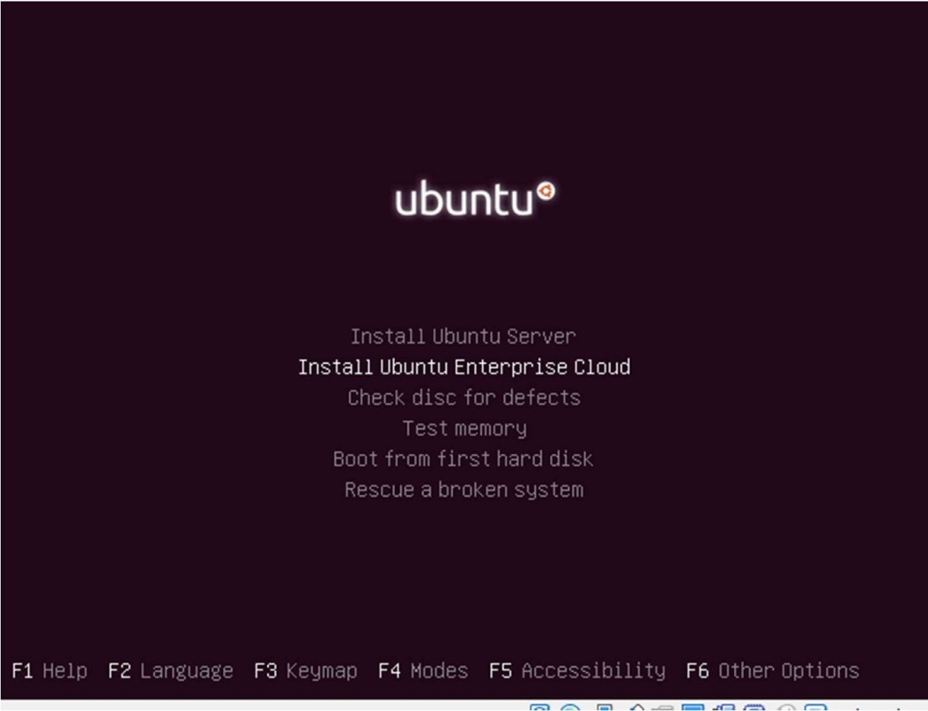

* 1. Create the VM with following steps:
  2. Host name for this server: cc

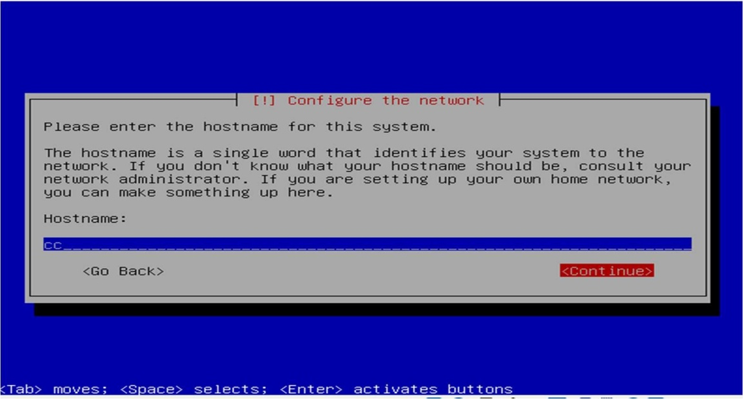

* 1. cloud controller address: leave as blank

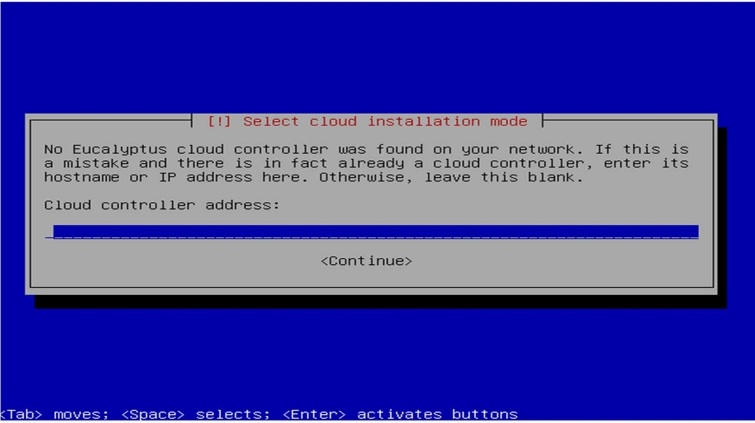

* 1. Cloud installation module : Cloud controller, Walrus storage service, Cluster controller, Storage controller

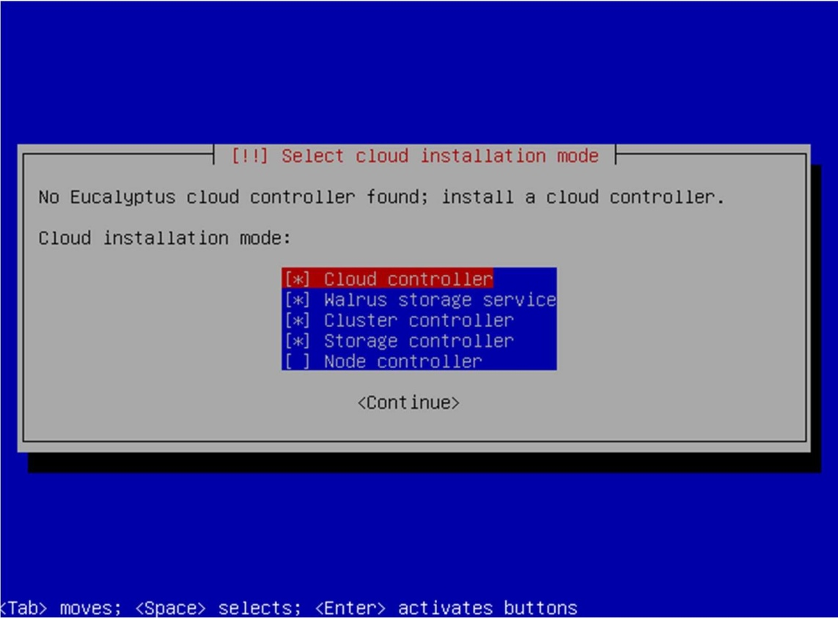

* 1. Partition disks select “Guided-use entries disk and set up LVM‟

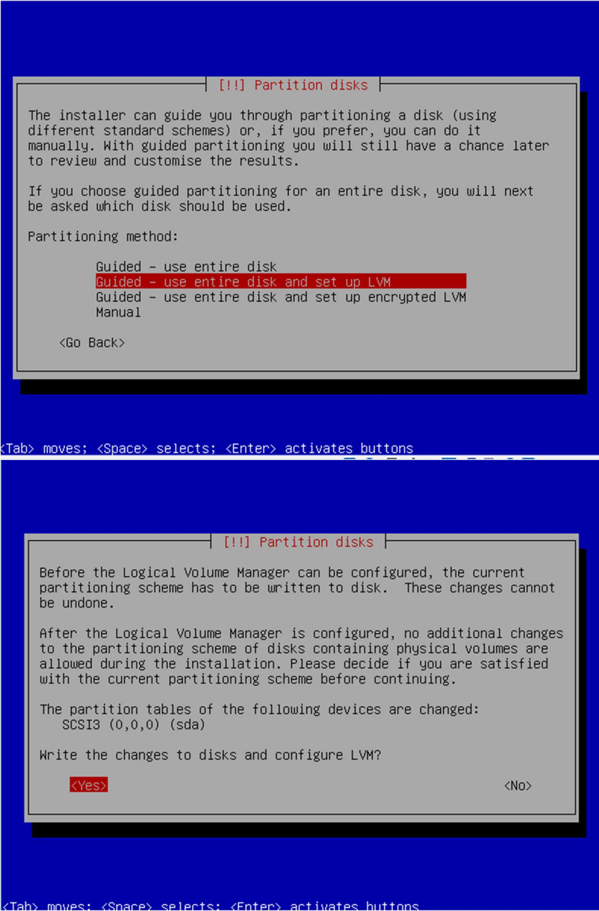

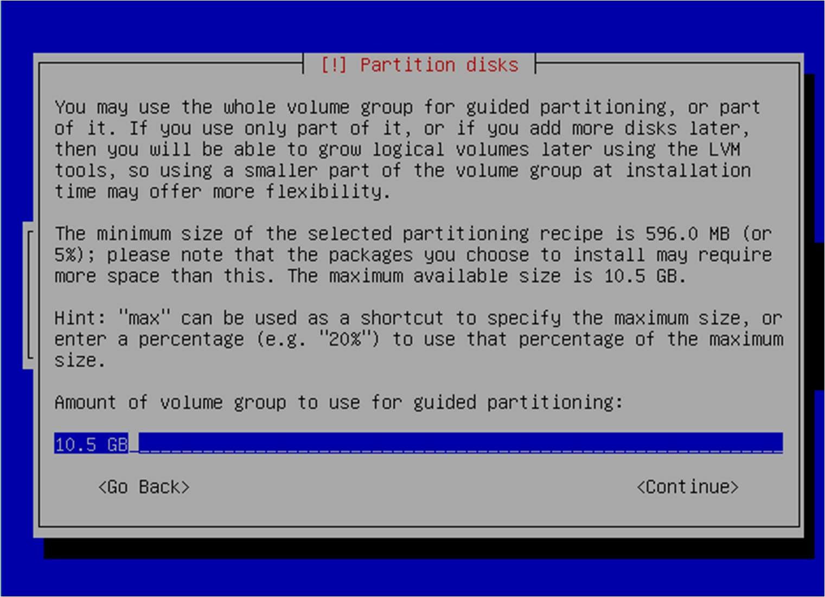

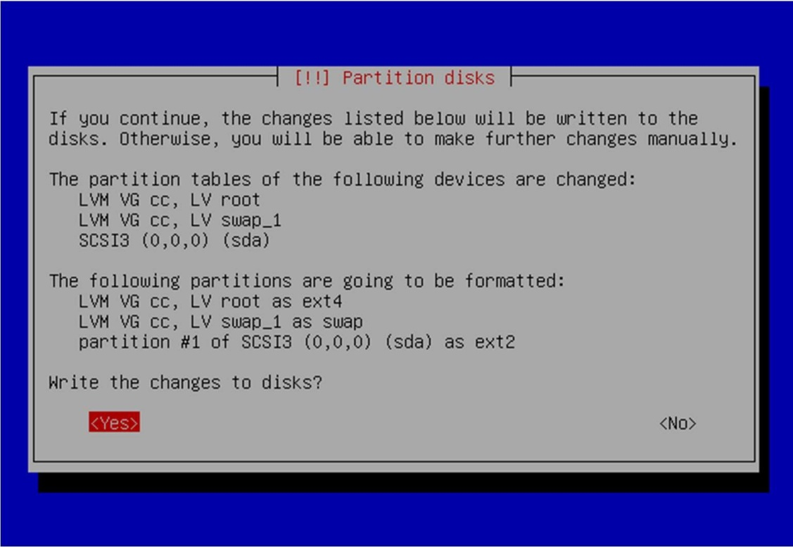

* 1. Full name for new user and username for account : cladmin

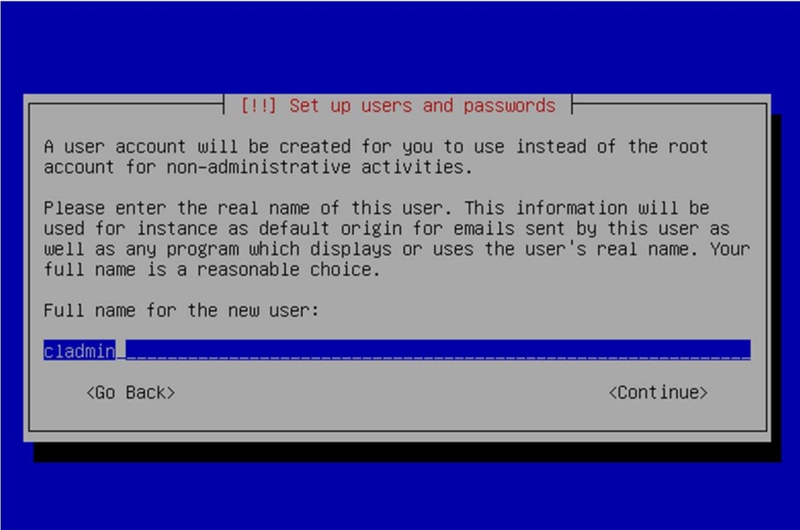

Give username as cladmin for your account

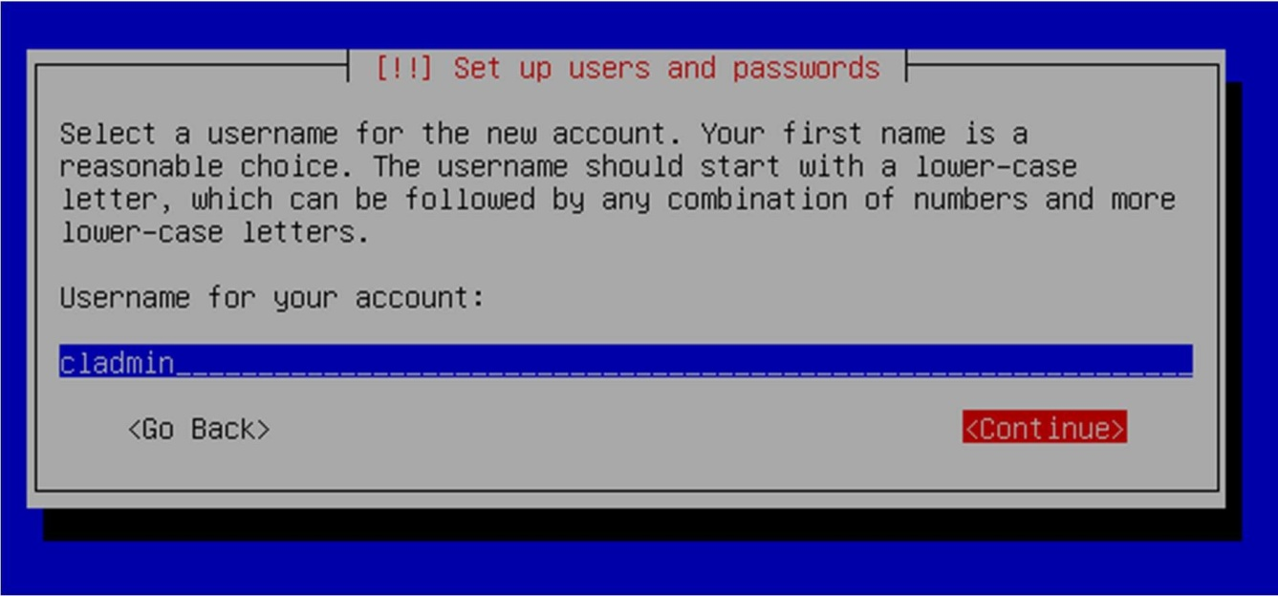

Choose password

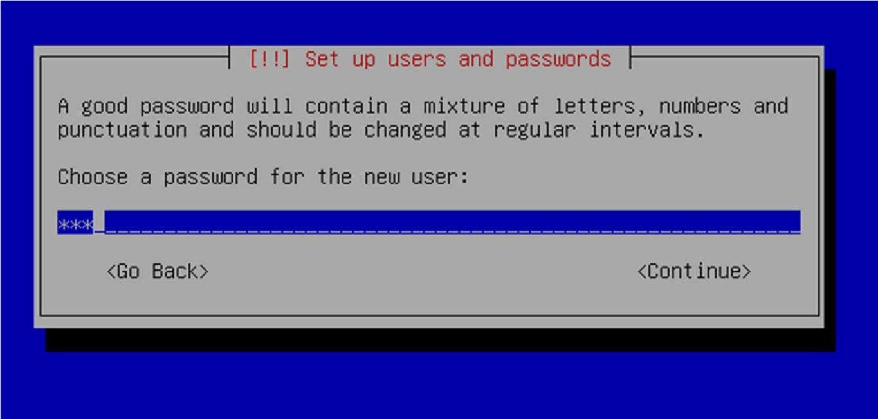

* 1. Select no automatic updates
  2. Eucalyptus cluster name : cluster1

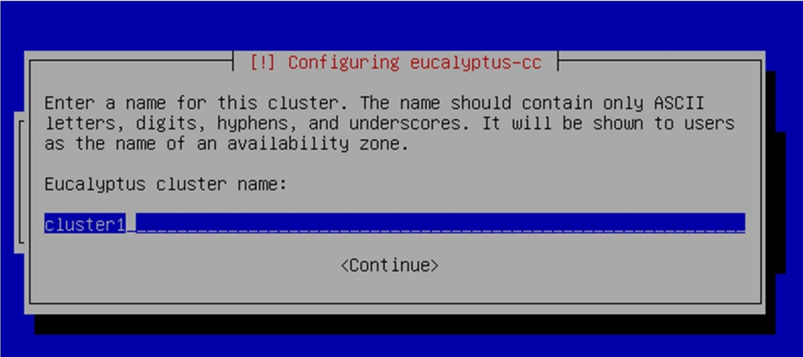

* 1. Leave pool of IP addresses blank
  2. Install grub boot loader and then reboot when installation complete

1. The installed VM1 is as below

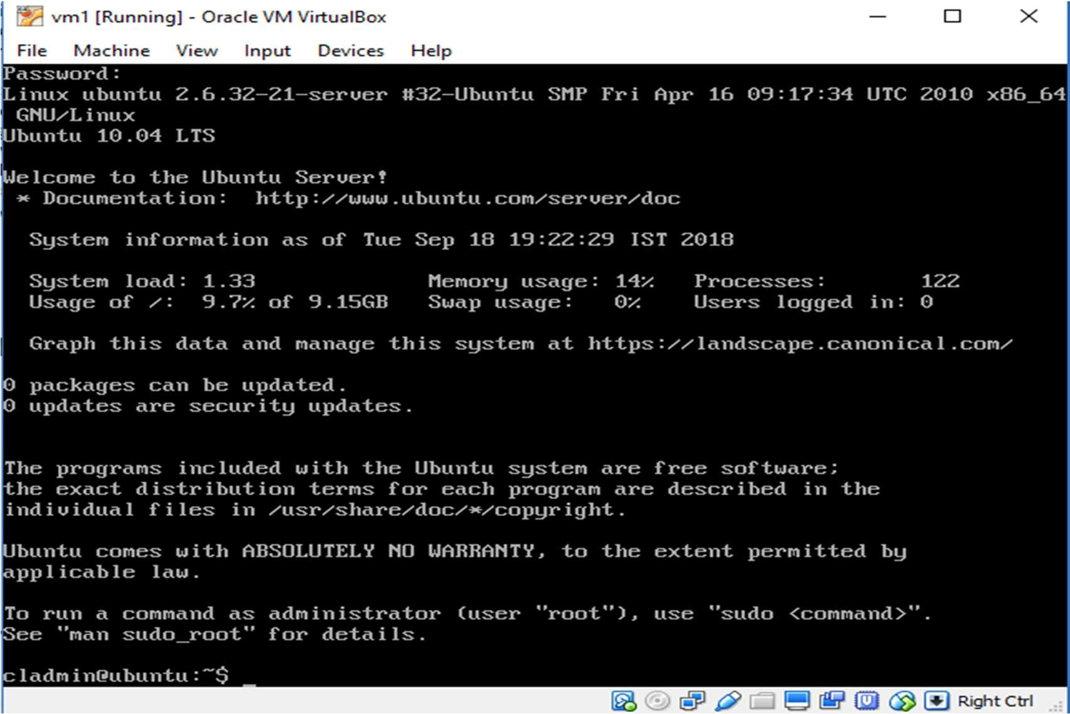

1. Install node controller in second VM namely VM2.
2. Install Desktop 16.04 ubuntu in VM3 that will act as client.
3. Install qemu-kvm in VM1.

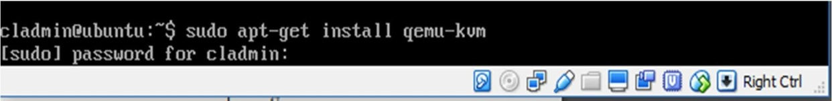

1. On node controller set a temporary password

###### $ sudo passwd eucalyptus

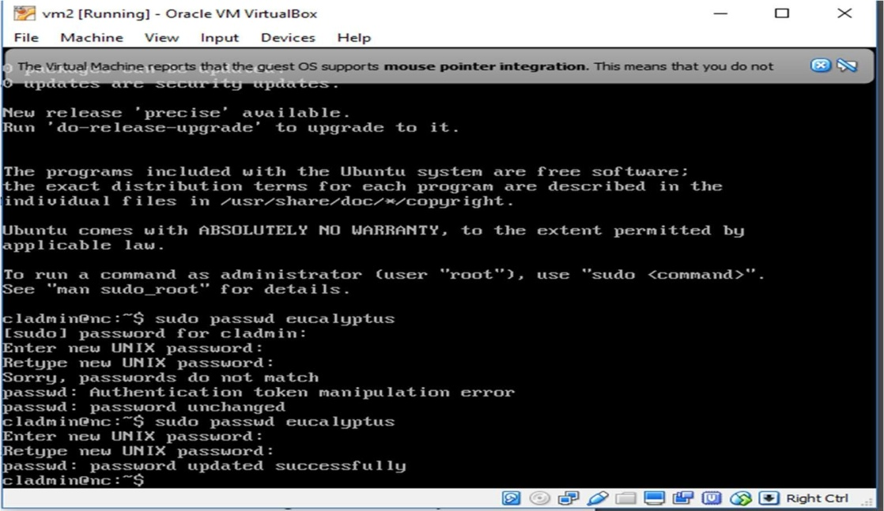

1. On cloud controller

###### $ sudo -u eucalyptus ssh-copy-id -i /var/lib/eucalyptus/.ssh/id_rsa.pub eucalyptus@<cloud-ip>

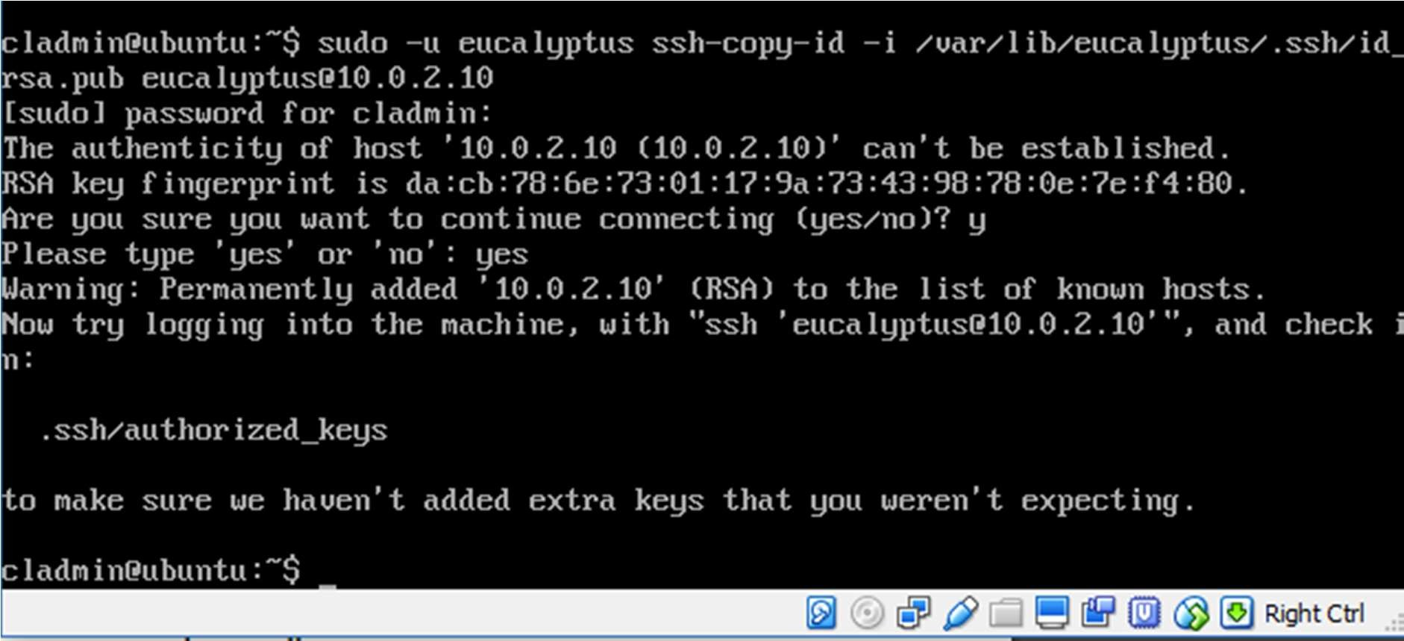

1. On node controller remove temporary password

###### $ sudo passwd -d eucalyptus

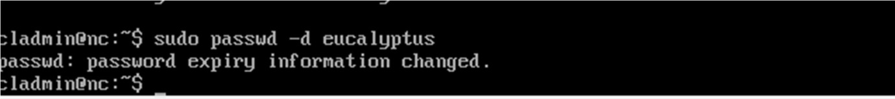

1. In VM3 Web Interface, login as **https://<cloud-ip>:8443**
2. 1 Username: admin Password: admin Check all the resources available. **U SE NO PROXY IN B ROWSER**

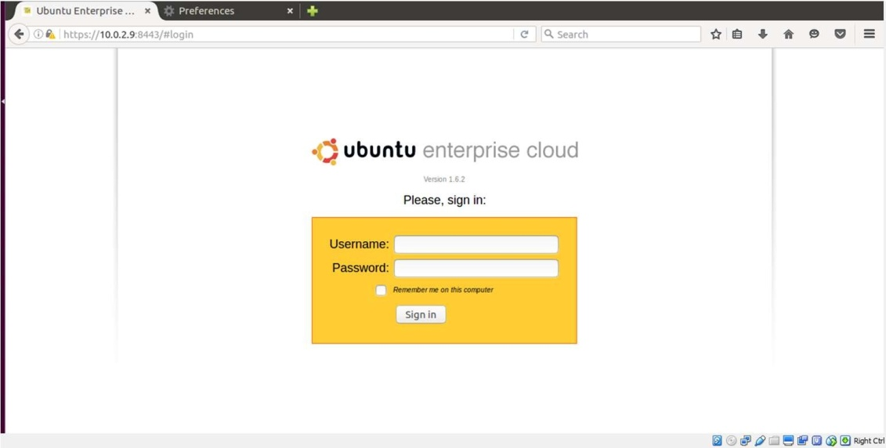

* 1. Use username 'admin' and password 'admin' for the first time login (you will be prompted to change your password). Then follow the on-screen instructions to update the admin password and email address.

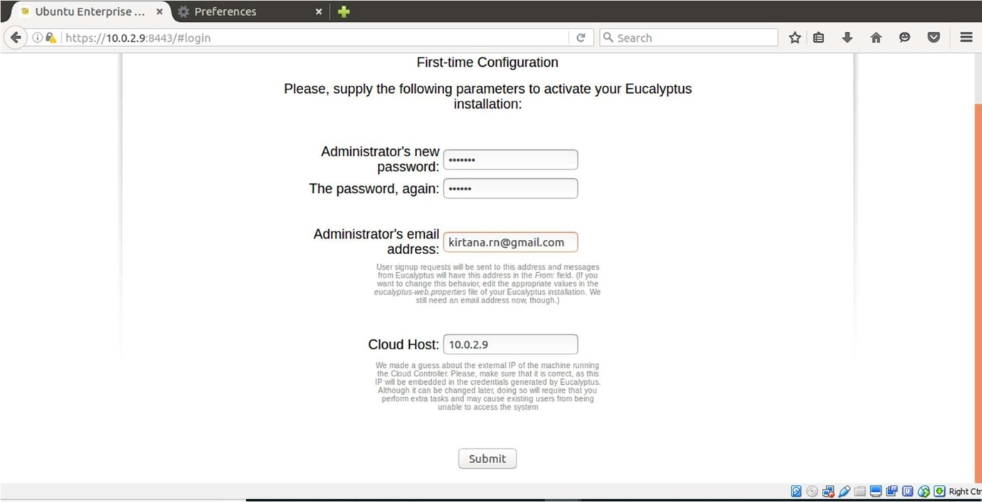

* 1. Check the user update as below.

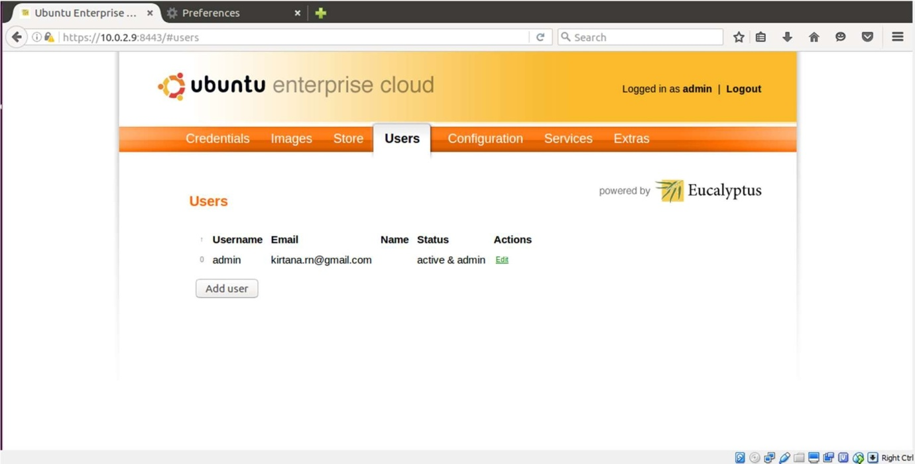

* 1. Once the first time configuration process is completed, click the 'credentials' tab located in the top-left portion of the screen. Click the 'Download Credentials' button to get your certificates.

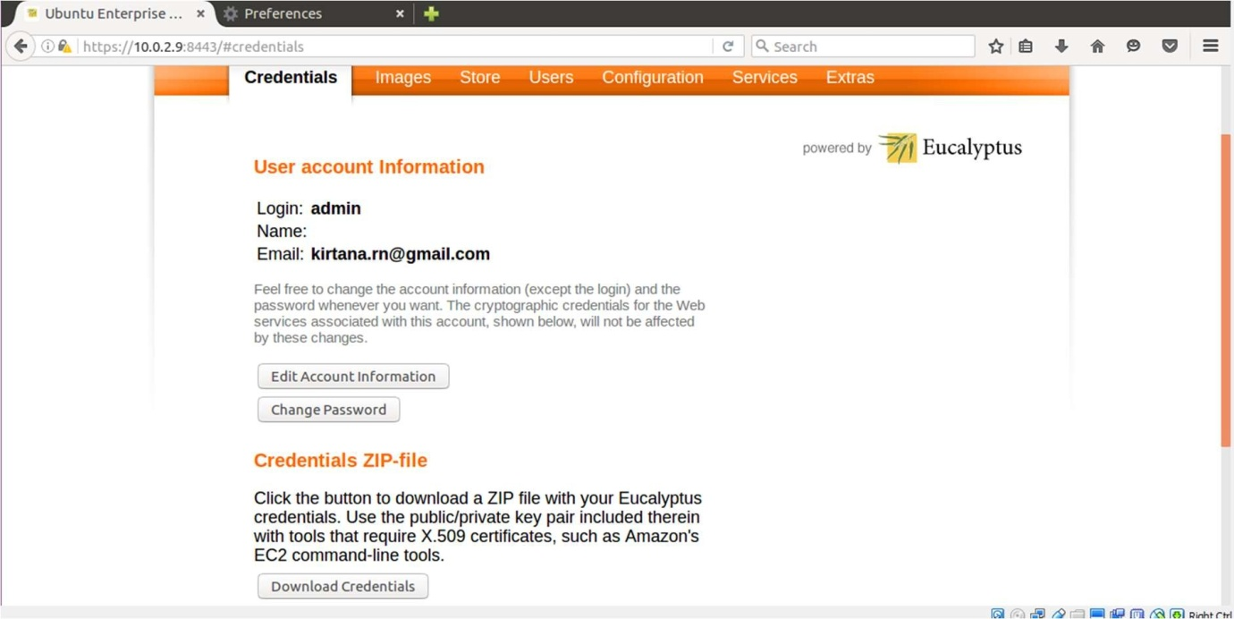

* 1. Download the file to the Downloads folder of client and transfer it to cloud controller ip.

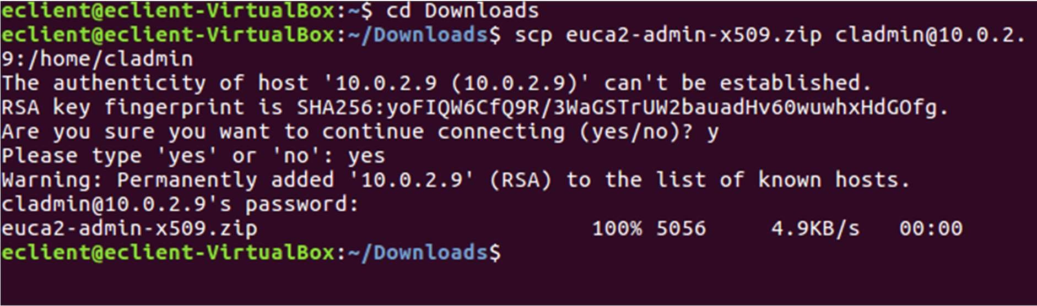

1. **In cloud controller,**

$] mkdir -p ~/.euca

$ cd ~/.euca

**change modes for ~/.euca and ~/.euca/* as below**



1. $ sudo euca_conf –get-credentials mycreds.zip to obtain credentials in cloud controller.

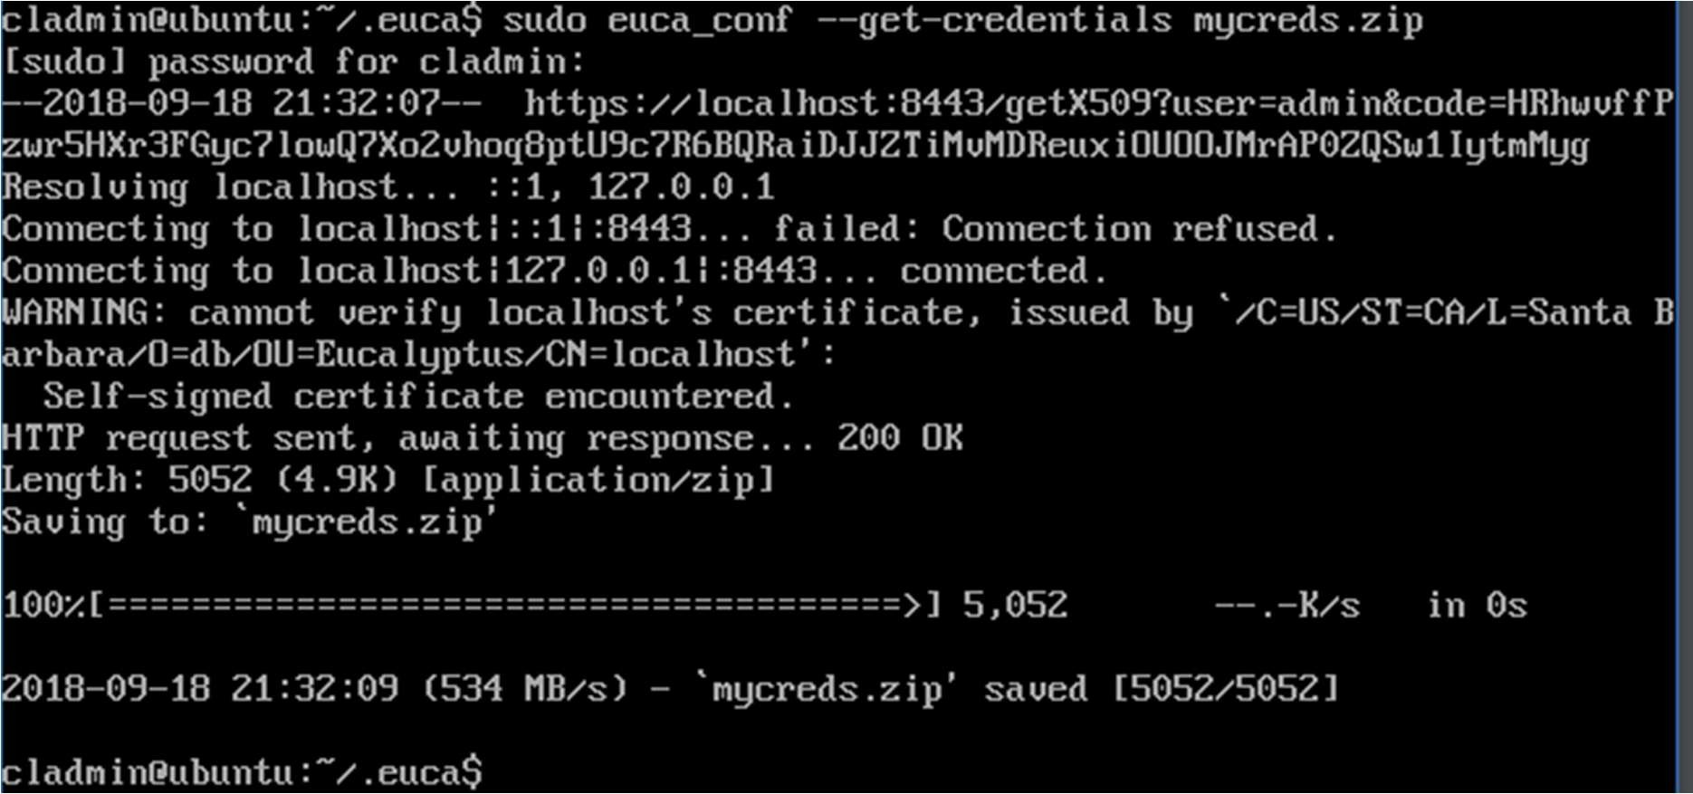

1. unzip mycreds.zip

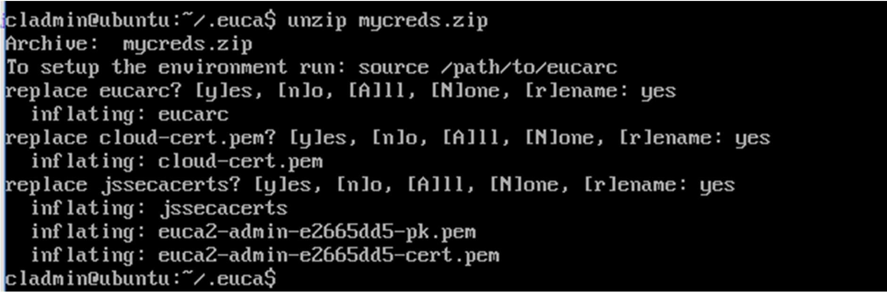

1. listing files in ~/.euca

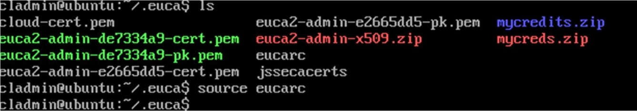

1. In client, make an update.

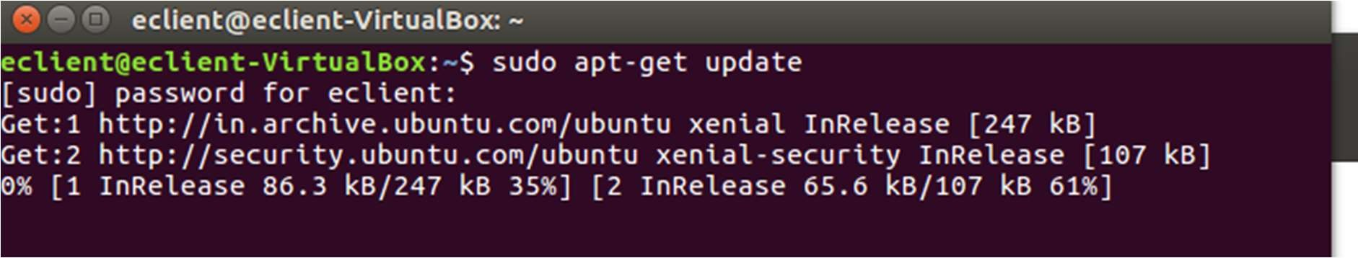

1. Install euca2ools using **sudo apt-get install euca2ools**

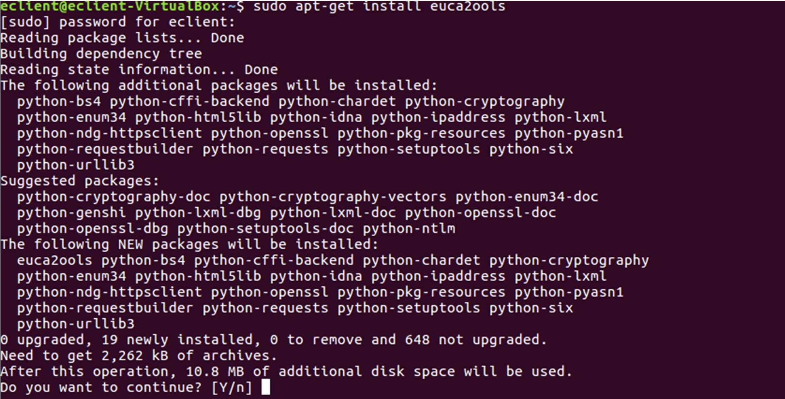

1. **Execute euca-create-volume and euca-describe-volumes using options as –U for URL , -I for access key and –S for secret key description**

The URL, SECRET KEY AND ACCESS KEY ARE OBTAINED from the file eucarc under

X.509 certificate folder that was downloaded as credentials.

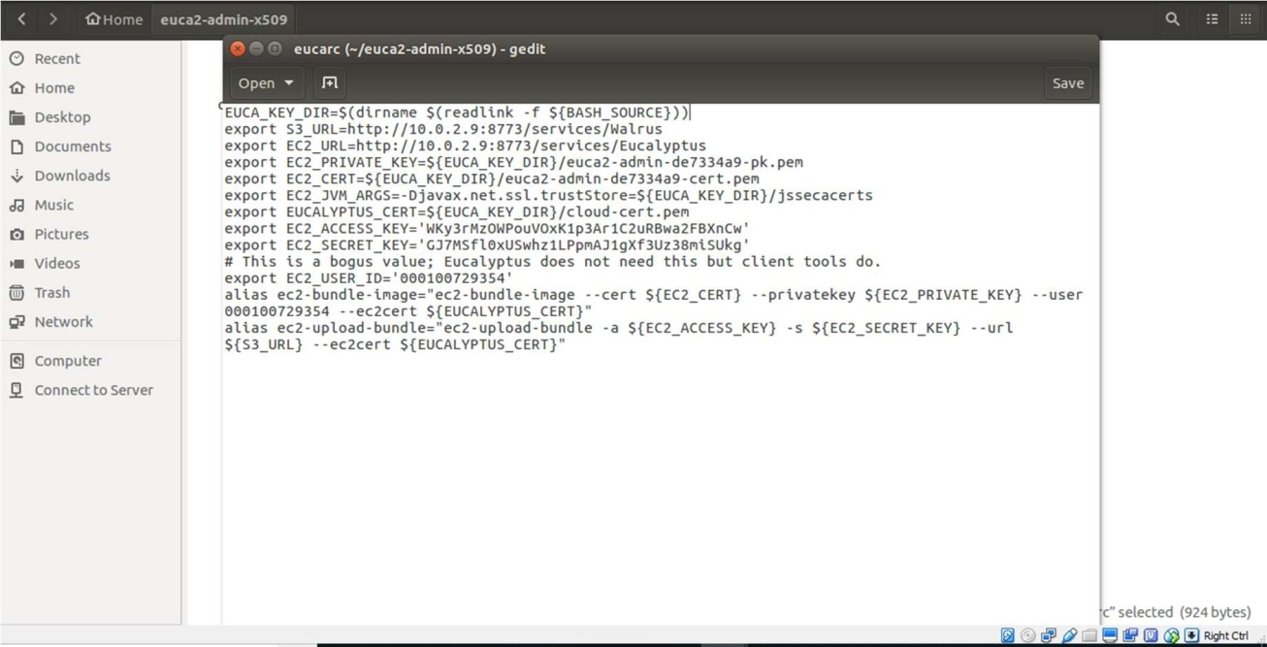

1. Execute as

**euca-create-volume –U <url> -I <accesskey> -S <secret_key> --size 1 –z <clustername>**

to describe as below:

**euca-describe-volumes –U <url> -I <accesskey> -S <secret_key>**

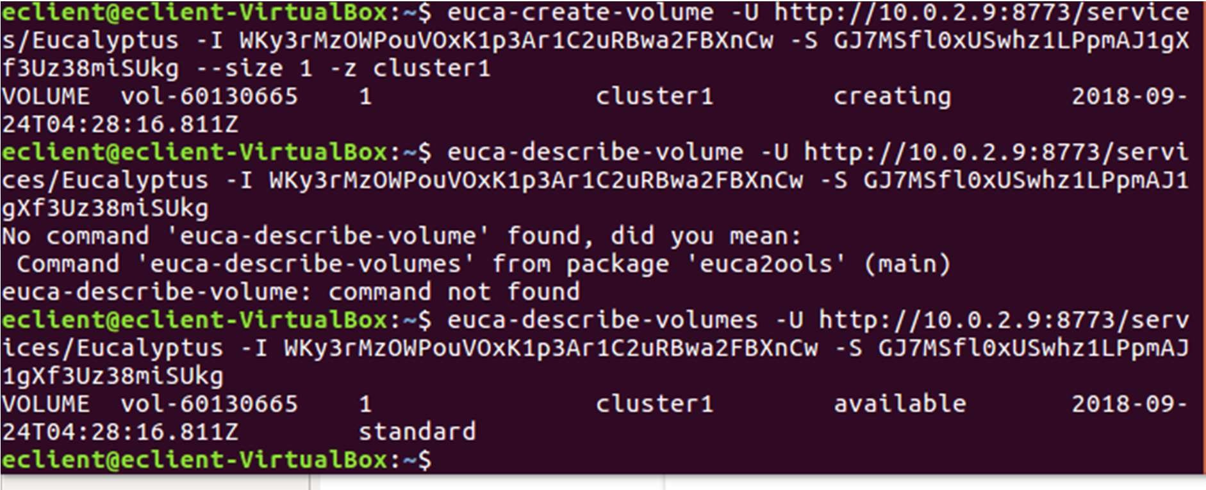

Result : Thus, a private cloud was set up using eucalyptus and volumes were created, described using client machine.